**January 2024 | Target Maps Revision**

**Target Maps**

**Change:** Periphyton targets revised from A to B in four WMZs

**Reason:** Translation from error from Cawthron targets report to WMZs

**Change:** *E. coli* targetsrevised down one grade (A to B or B to C) in 14 WMZs

**Reason:** Translation from error to WMZs

**Reductions Required Maps**

**Change:** 20 WMZs have a different category status (e.g. from small reduction to moderate reduction) for Total Nitrogen. Five WMZs have improved in reductions required and 15 now require larger reductions.

**Reason:** Update to the model used and changes to periphyton targets

**Change:** 13 WMZs have a different category status (e.g. from small reduction to moderate reduction) for Total Phosphorous. 10 WMZs have improved in reductions required and 3 now require larger reductions.

**Reason:** Update to the model used and changes to periphyton targets

**Change:** 8 WMZs have an improvement in category status (e.g. from small reduction to moderate reduction) for *E. coli*.

**Reason:** Changes to *E. coli* targets

**Mitigation Effectiveness Maps**

**Change:** 35 WMZs have a different category status (e.g. from actions likely to achieve to actions within 20% of target) for Total Nitrogen. 9 WMZs have an improved a catergory and are now more likely that the mitigations will achieve the periphyton target. 26 WMZs have a worse category and are less likely to reach targets for the modelled mitigations.

**Reason:** Update to the model used and changes to periphyton targets.

**Change:** 14 WMZs have a different category status e.g. from actions likely to achieve to actions within 20% of target) for Total Phosphorous. 7 WMZs have an improved a catergory and are now more likely that the mitigations will achieve the periphyton target. 7 WMZs have a worse category and are less likely to reach targets for the modelled mitigations.

**Reason:** Update to the model used and changes to periphyton targets.

**Change:** 7 WMZs have a different category status (e.g. from actions likely to achieve to actions within 20% of target) for *E. coli*. All 7 WMZs have an improved a catergory and are now more likely that the mitigations will achieve the *E. coli* targets.

**Reason:** Changes to *E. coli* targets

**Periphyton targets (OLD = LEFT,    NEW = RIGHT):**

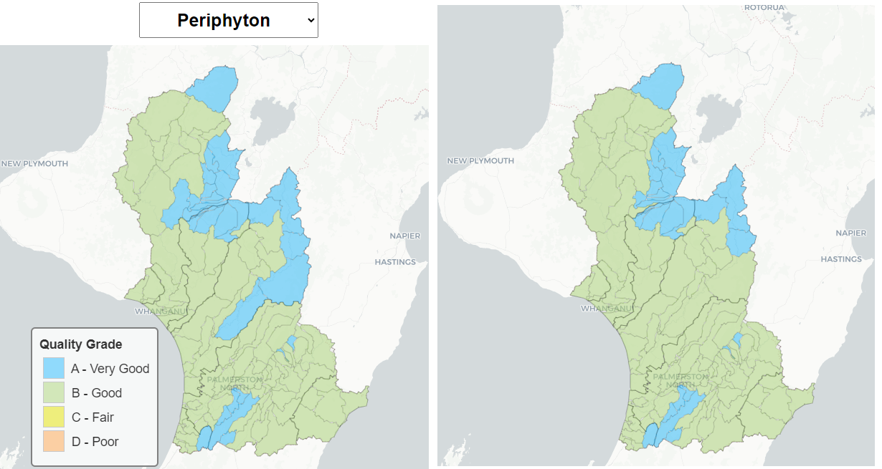

**Reductions required NITROGEN**

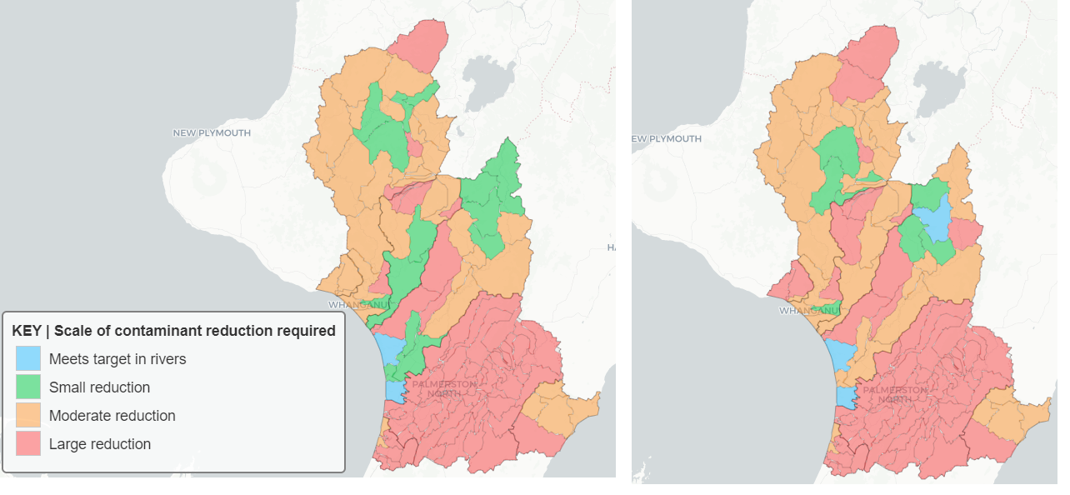

**Reductions required PHOSPHORUS**

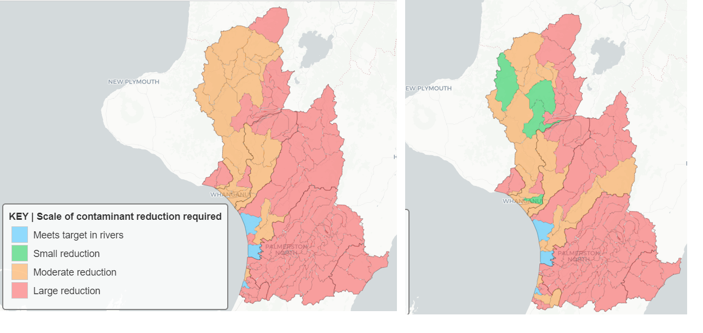

**Mitigation effectiveness NITROGEN**

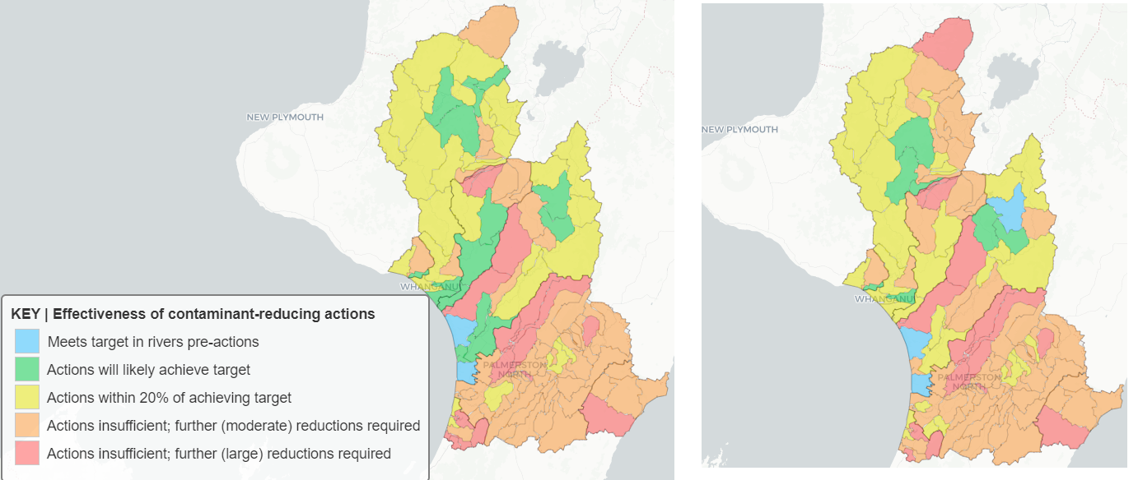

**Mitigation effectiveness PHOSPHORUS**

